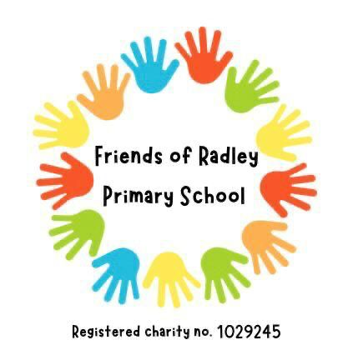

7th November 2022

Dear Parents and Carers

As you may know, Radley CE Primary will be celebrating its 150th anniversary in January 2023. To help mark the occasion, the Friends of Radley School are putting together a commemorative tea towel including all the current pupils – and we need your help, please!

Each child has received or will receive an Individual Self-Portrait Drawing Template. Please could your child draw a self-portrait in the box – head only rather than full length portrait please! If they can, they should then write their name in the smaller box underneath, first name and initial only please. Please feel free to help if need be! The template says black pen only, but the children can use any colours they would like to. Colouring pens or pencils only please (and be aware that it will only be one colour on the tea towel). Would an adult then please fill in the child’s name and class at the bottom. Please see the terribly drawn example below. I’m sure the children’s will be a huge improvement…

We would be grateful if you could please return the drawings to school by **25th November latest**, to give us enough time to have the tea towels laid out and printed for January. We will be in touch closer to the time with details on how to order yours! If you would rather your child not be included, just let Mrs Crook in the office know.

A huge thank you in advance for your support. If you have any queries, or need an additional sheet, please get in touch with Gemma Fraser on 07971 109120 or [gemma.fraser@hotmail.com](mailto:gemma.fraser@hotmail.com). We can’t wait to see all the portraits!

With best wishes

The Friends Committee

